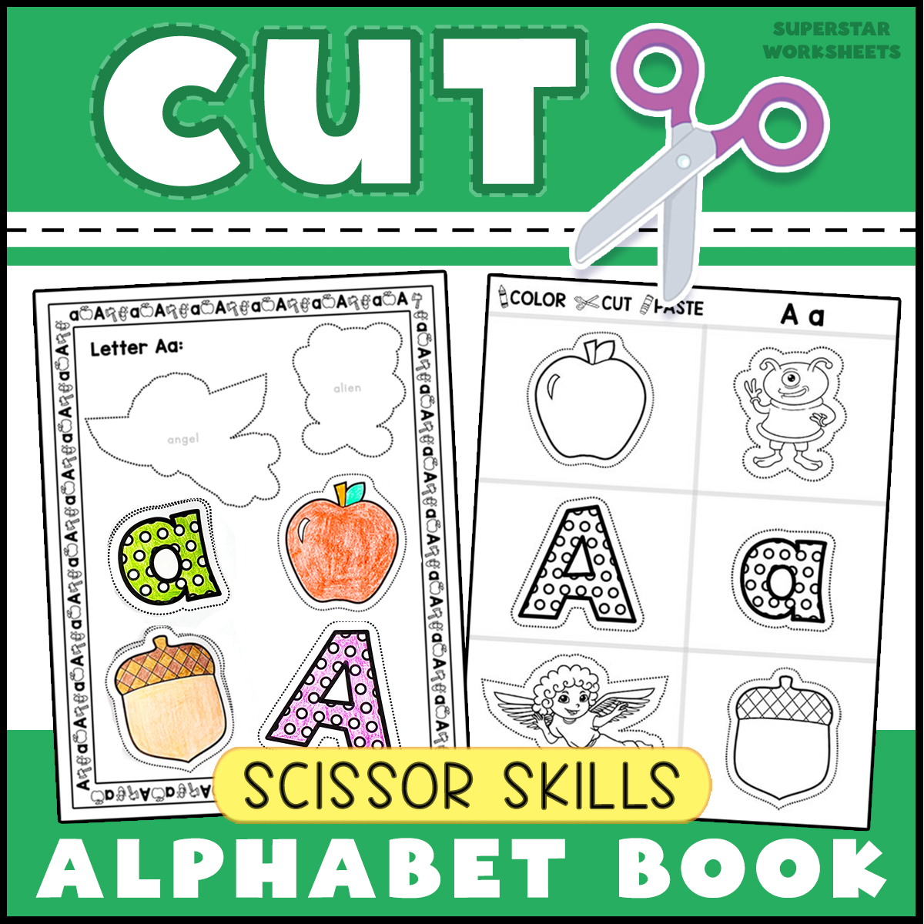

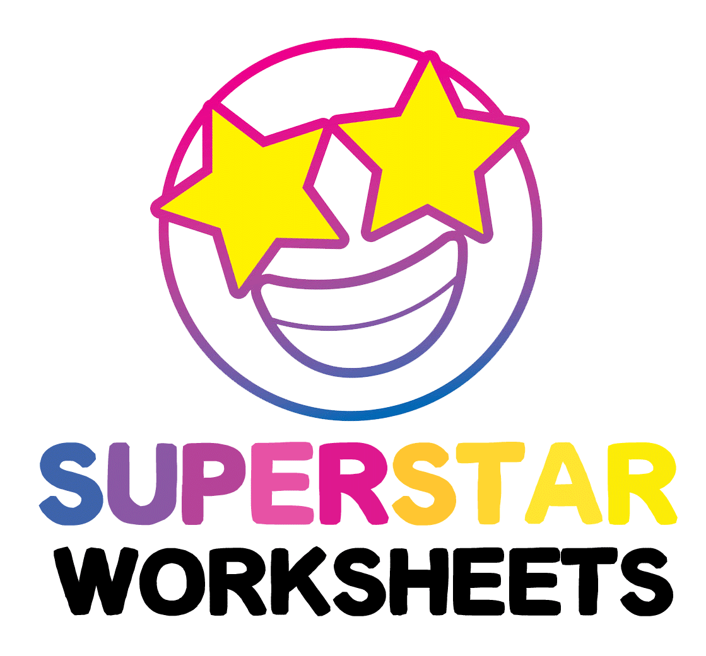
CUT SCISSOR SKILLS BUNDLE

Full Copyright Valerie McClintick LLC
Images & Fonts Full Copyright: Dancing Crayon Designs, Digital Mojo, Lidia Barbosa Clipart
Contents of this download are not to be stored in any sort of file sharing system or printed in mass quantity. Piracy Copyright Laws Apply, do not link directly to this PDF file, or in any manner present this file as your own digital content. Images hold full copyright and are not to be manipulated or altered in any way. You may not distribute this file in digital or physical format. This digital file, or the printed variation is not to be sold, or given away freely in any manner, including selling or giving away as a preassembled version of the product. This file is for your own personal homeschool, classroom, or educational use only. Please ensure you have purchased the proper licensing for classroom use.
For all copyright questions, please contact Valerie McClintick LLC: support@thecraftyclassroom.com

Visit our Shop for more Hands-On Learning:
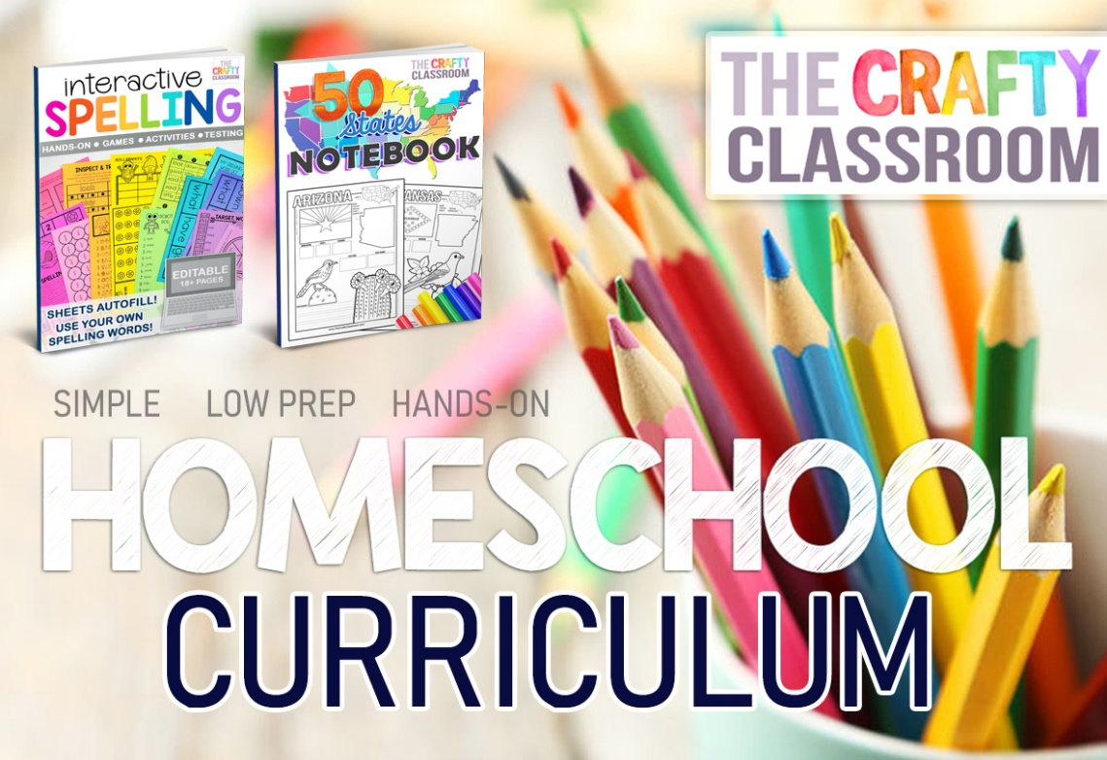
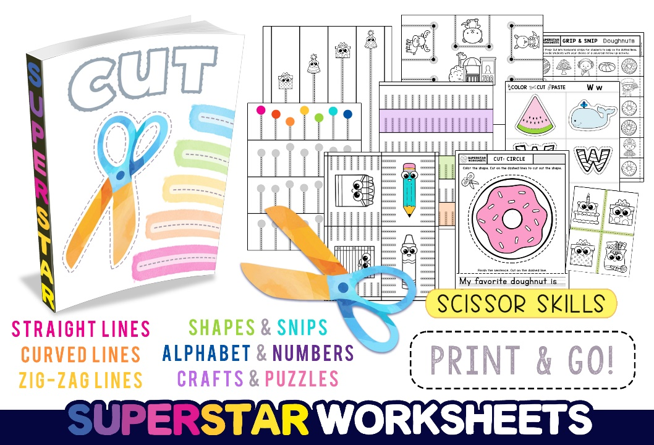

Product Features:
These cut and paste alphabet activities are super engaging for preschool ages practicing their fine motor skills. Not only will they learn their ABCs, but they’ll also have a ton of fun with hands-on activities including coloring, cutting, matching and pasting the entire alphabet along with recognizing basic objects.
How to Use:
Your young student will improve their cutting and pasting consistently and creatively using scissors, glue, and coloring utensils. These printable pages can be used for recognizing ABCs and popular images made into a creative and colorful picture. Students will be provided a lot of coloring practice, as they can color each page before cutting the adorable images, matching, and pasting them onto the picture.
Needs:
Students will need coloring utensils, scissors, and glue.

